SYSTEM PROGRAMMING LABORATORY
(CSX-326)

LAB PRACTICALS RECORD

COMPUTER SCIENCE AND ENGINEERING



DEPARTMENT OF COMPUTER SCIENCE AND ENGINEERING
Dr. B R AMBEDKAR NATIONAL INSTITUTE OF TECHNOLOGY
JALANDHAR – 144011, PUNJAB (INDIA)
January - June, 2016

Submitted To: Submitted By:
Mrs. Kamalpreet Kaur Nikhil Bansal
Asst. Professor 13103011
Dept. of CSE 6th semester

1. | Objective:-To implement Linear search.

Program:
#include<bits/stdc++.h>
using namespace std;

int linearsearch(int array[],int start, int end, int search)
{
int i;
for(i=start;i<=end;i++){
if(array[i]==search)
break;
}
if(i<=end)
return i;
else
return -1;
}

int main()
{
int array[1000],n,search,i;

//input of array
printf("Enter the number of integers in array\n");
scanf("%d",&n);
printf("Enter the elements of array\n");
for(i=0;i<n;i++)
{
scanf("%d",&array[i]);
}

//get query and output the result
while(1){
printf("Press 0 to stop. Enter the element you want search:\n");
scanf("%d",&search);
if(search==0)
break;

i = linearsearch(array,0,n-1,search);

if(i==-1)
printf("Element %d not found\n",search);
else
printf("Element %d found at %d index\n",search,i);
}
return 0;
}

Output:
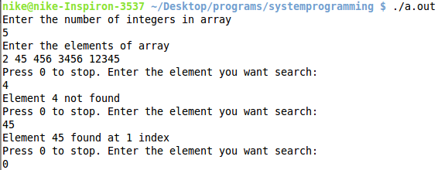

2. | Objective:-To implement Binary search.

Program:
#include<bits/stdc++.h>
using namespace std;

int binarysearch(int array[],int start, int end, int search)
{
if(start>end)
return -1;

int mid=(start+end)/2;

if(array[mid]==search)
return mid;
else if(array[mid]>search)
return binarysearch(array, start, mid-1, search);
else
return binarysearch(array, mid+1, end, search);
}

int main()
{
int array[1000],n,search,i;

//input of array
printf("Enter the number of integers in array\n");
scanf("%d",&n);
printf("Enter the elements of array\n");
for(i=0;i<n;i++)
{
scanf("%d",&array[i]);
}

//sort if the array is not sorted
sort(array, array+n);

//input query and display output
while(1){
printf("Press 0 to stop. Enter the element you want search:\n");
scanf("%d",&search);
if(search==0)
break;

i = binarysearch(array,0,n-1,search);

if(i==-1)
printf("Element %d not found\n",search);
else
printf("Element %d found at %d index\n",search,i);
}
return 0;
}

Output:
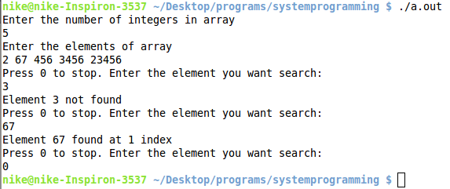

3. | Objective:-To implement Merge Sort

Program:
#include<bits/stdc++.h>
using namespace std;

//print function to display array
int print(int array[],int start,int end){
int i;
for(i=start;i<=end;i++){
printf("%d ",array[i]);
}
printf("\n");
return 0;
}

//returns the copy of array elemets
int* copy(int array[],int start,int end){
int i,*copy_arr=(int *)malloc(sizeof(int)*(end-start+1));
for(i=start;i<=end;i++){
copy_arr[i-start]=array[i];
}
return copy_arr;
}

//merge the 2 sorted arrays
int merge(int array[],int start,int end,int firsthalf[],int secondhalf[]){

int i=0,j=0,mid=(start+end)/2,sizefirst=mid-start+1,sizesecond=end-mid;
int k=0,size=end-start;

while(k!=size){
if(i==sizefirst||j==sizesecond)
break;
if(firsthalf[i]>secondhalf[j]){
array[start+k]=secondhalf[j];
j++;
}
else{
array[start+k]=firsthalf[i];
i++;
}
k++;
}

while(i<sizefirst){
array[start+k]=firsthalf[i];
i++;
k++;
}

while(j<sizesecond){
array[start+k]=secondhalf[j];
j++;
k++;
}
return 0;
}

//main merge sort function
int mergesort(int array[],int start,int end){
if(start>=end)
return 0;
int mid;
mid=(start+end)/2;

//sort the 2 sub-arrays
mergesort(array,start,mid);
mergesort(array,mid+1,end);

//create the copy of 2 subarrays
int *firsthalf=copy(array,start,mid);
int *secondhalf=copy(array,mid+1,end);

// merge them in the main array
merge(array,start,end,firsthalf,secondhalf);

//free the malloc memory allocated for copies.
free(firsthalf);
free(secondhalf);
return 0;
}

int main()
{
int n,i,temp,array[1000];

//input
printf("Enter the number of elements\n");
scanf("%d",&n);
printf("Enter the elements of array\n");
for(i=0;i<n;i++)
{
scanf("%d",&array[i]);
}

//sort
mergesort(array,0,n-1);

//output array
printf("Sorted Array: ");
print(array,0,n-1);
printf("\n");
return 0;
}

Output:
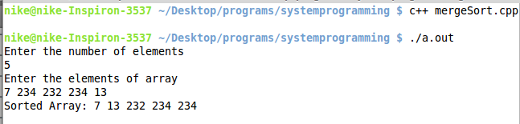

4. | Objective:-To implement QuickSort

Program:
#include<stdio.h>
#include<malloc.h>

//partition function to divide the arrary about a pivot
int partition(int *a,int i,int j){
int v=j,u=i+1,w;
while(v>=u){
for(;u<=j;u++){
if(a[u]>a[i])
break;
}
for(;v>=i;v--){
if(a[v]<a[i])
break;
}
if(v>u){
w=a[u];
a[u]=a[v];
a[v]=w;
}
}
if(v==i-1){
return u-1;
}
else{
return v;
}
}

//main quick sort function
int quicksort(int *a,int i,int j){
if(i>=j)
return 0;
int u,w;
u=partition(a,i,j);
w=a[i];
a[i]=a[u];
a[u]=w;
quicksort(a,i,u-1);
quicksort(a,u+1,j);
return 0;
}

int main(){
int n,*a,i,s;

//input
printf("enter the no. of elements in array\n");
scanf("%d",&n);
a=(int *)malloc(sizeof(int)*n);

printf("enter the elements of array\n");
for(i=0;i<n;i++){
scanf("%d",&a[i]);
}

//sort
quicksort(a,0,n-1);

//print the sorted array
printf("the sorted array is \n");
for(i=0;i<n;i++){
printf("%d ",a[i]);
}

return 0;
}

Output:
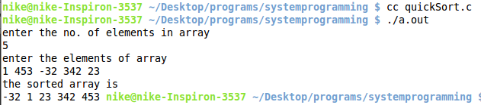

5. | Objective:-To implement Bubble Sort

Program:
#include<bits/stdc++.h>
using namespace std;

int bubblesort(int array[],int start,int end)
{
int i,j,temp;
for(i=start;i<=end;i++)
{
for(j=start;j<end-i;j++)
{
if(array[j]>array[j+1])
{
temp=array[j];
array[j]=array[j+1];
array[j+1]=temp;
}
}
}
return 0;
}

int main()
{
int n,i,temp,array[1000];

//input
printf("Enter the number of elements\n");
scanf("%d",&n);
printf("Enter the elements of array\n");
for(i=0;i<n;i++)
{
scanf("%d",&array[i]);
}

//sort
bubblesort(array,0,n-1);

//print output array
printf("Sorted Array: ");
for(i=0;i<n;i++)
{
printf("%d ",array[i]);
}
printf("\n");
return 0;
}

Output:
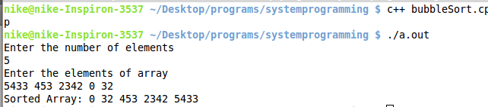

6. | Objective:-To implement Bucket Sort

Program:
#include<bits/stdc++.h>
using namespace std;
#define NO_OF_BUCKET 100000
#define BUCKET_SIZE 1000

int bucketsort(int array[],int start,int end){
vector<int> buckets[NO_OF_BUCKET];
int i,j,k,size;

//push the elements of array to appropriate bucket
for(i=start;i<=end;i++){
buckets[array[i]/BUCKET_SIZE].push_back(array[i]);
};

//sort each bucket by inbuilt sort function
for(i=0;i<NO_OF_BUCKET;i++){
sort(buckets[i].begin(),buckets[i].end());
}

//update the array with sorted array
k=start;
for(i=0;i<NO_OF_BUCKET;i++){
size=buckets[i].size();
for(j=0;j<size;j++){
array[k]=buckets[i][j];
k++;
}
}

return 0;
}

int main()
{
int n,i,temp,array[1000];
int arrayint[1000];

//input
printf("Enter the number of elements\n");
scanf("%d",&n);
printf("Enter the elements of array\n");
for(i=0;i<n;i++)
{
scanf("%d",&arrayint[i]);
array[i]=arrayint[i]*10000;
}

//sort
bucketsort(array,0,n-1);

//print sorted array
printf("Sorted Array: ");
for(i=0;i<n;i++)
{
arrayint[i]=1.00*array[i]/10000;
printf("%d ",arrayint[i]);
}
printf("\n");

return 0;
}

Output:
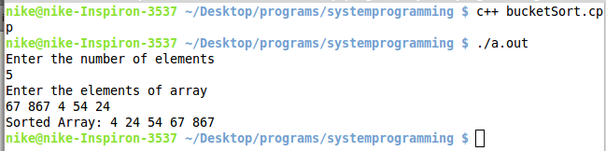

7. | Objective:-To find frequency of a letter in text

Program:
#include<bits/stdc++.h>
using namespace std;
int main()
{
FILE *input = fopen("charactersinput.txt", "r");
char temp, search;
int ans=0;
printf("Enter the character\n");
scanf("%c",&search);
while((temp=fgetc(input))!=EOF)
{
if(temp==search)
ans++;
}
printf("Character %c occured %d times\n",search,ans);
return 0;
}

Output:
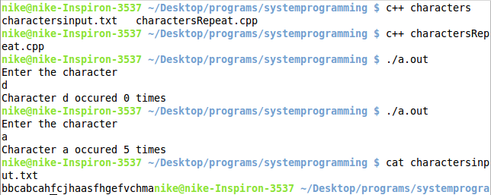

8. | Objective:-Text Editor

Program:
#include<bits/stdc++.h>
using namespace std;

// display the contens of a file
// returns -1 if doesnot exist
int displayFile(char filename[]){
FILE *myFile=fopen(filename, "r");
if(myFile==NULL)
return -1;
char c;
while((c=fgetc(myFile))!=EOF){
printf("%c",c);
}
fclose(myFile);
return 0;
}

// create the file
// returns -1 if creation failed
int createFile(char filename[]){
FILE *myFile=fopen(filename, "w");
if(myFile==NULL)
return -1;
fclose(myFile);
return 0;
}

// append the contents in file
int appendDataToFile(char filename[], char data[]){
FILE *myFile=fopen(filename, "a");
if(myFile==NULL)
return -1;
for(int i=0;data[i]!='\0';i++){
fputc(data[i], myFile);
}
fclose(myFile);
return 0;
}

// delete the contents in file
int deleteFile(char filename[]){
int x=remove(filename);
return x;
}

// get data to append
// stops the input data once :q is received
void inputDataToAppend(char data[]){
printf("Enter the data.\nPress :q to stop entering data.\n");
int flag1=0, flag2=0, top=0;
char buffer;
// for redundant new line character that gets received.
scanf("%c",&buffer);
while(top<1000){
scanf("%c",&buffer);
if(buffer==':'){
flag1=1;
}
else if(buffer=='q'){
flag2=1;
}
else{
flag1=0;
flag2=0;
}
if(flag1==1&&flag2==1){
data[top-1]='\0';
break;
}
data[top]=buffer;
top++;
}
if(top==1000){
printf("Buffer Overflow\n");
}
}
int main(int argc, char const *argv[])
{
char filename[100],data[1000];
int operation,err;
while(1){
system("sleep 2");
system("clear");
printf("1 -> Create File\n2 -> Display File\n3 -> Append Data to File\n4 -> Delete File\n5 -> Exit\n");
printf("Choose any operation: ");
scanf("%d",&operation);
switch(operation){
case 1:
printf("Enter the File Name: ");
scanf("%s",filename);
err=createFile(filename);
if(err==-1)
printf("File cannot be created\n");
else
printf("File created successfully\n");
break;
case 2:
printf("Enter the File Name: ");
scanf("%s",filename);
err=displayFile(filename);
if(err==-1)
printf("File cannot be displayed\n");
break;
case 3:
printf("Enter the File Name: ");
scanf("%s",filename);
inputDataToAppend(data);
appendDataToFile(filename, data);
printf("\nData appended to File: %s\n",filename);
break;
case 4:
printf("Enter the File Name: ");
scanf("%s",filename);
err=deleteFile(filename);
if(err==-1)
printf("File cannot be deleted\n");
else
printf("File deleted successfully\n");
break;
case 5:
printf("Exiting.....\n");
exit(0);
break;
default:
printf("Enter a Valid Option\n");
}
}

return 0;
}

Output:

File Creation:
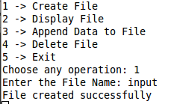

Data Append:
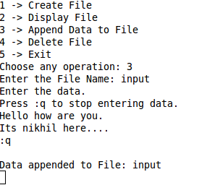

Display File:
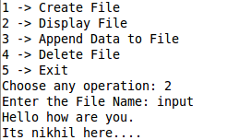

Delete File:
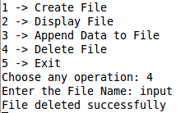

10. | Objective:- Write a program to make a two Pass-Assembler

Program:
#include<bits/stdc++.h>
using namespace std;
int main()
{
FILE *fp,*f1,*f2;
char arr[10], temp[10];
int value[]={1432,1324,3234,1998,2734,1256};
int count=ORG,arg1,val,i;
fp=fopen("input.in","r");
f1=fopen("intermediate.out","w");
f2=fopen("output.out","w");
char inst[][10]={"LDA","MOV","ADD","STA","HLT"};
int code[]={37,40,80,32,76};
int len[]={3,3,2,3,1};
int no;
while(!feof(fp))
{
fprintf(f1,"%d ",count);
fprintf(f2,"%d ",count);
fscanf(fp,"%s",arr);
fscanf(fp,"%d",&no);
fprintf(f1,"%s ",arr);
fprintf(f1,"%d\n",no);

for(i=0;i<5;i++)
if(!strcmp(arr,inst[i]))
{
val=i;
break;
}
if(i==4)
{
fprintf(f1,"%s",arr);
fprintf(f2,"%d",code[i]);
exit(0);
}
if(i==5)
{
printf("Invalid Instruction\n");
printf("Program about to end\n");
exit(0);
}

fprintf(f2,"%d ",code[i]);
fprintf(f2,"%d\n",no);
count+=len[i];
}
fclose(fp);
fclose(f1);fclose(f2);
return 0;
}

Input:
LDA 3700
MOV 52
LDA 3800
ADD 25
STA 3016
HLT

Intermediate:
2000 LDA 3700
2003 MOV 52
2006 LDA 3800
2009 ADD 25
2011 STA 3016
2014 HLT 3016
HLT

Output:
2000 37 3700
2003 40 52
2006 37 3800
2009 80 25
2011 32 3016
2014 76

11. | Objective:- Write a program for Lexical Analyser

Description:
In computer science, lexical analysis is the process of converting a sequence of characters into a sequence of tokens, i.e. meaningful character strings. A program or function that performs lexical analysis is called a lexical analyzer, lexer, tokenizer, or scanner, though "scanner" is also used for the first stage of a lexer. A lexer is generally combined with a parser, which together analyze the syntax of programming languages, such as in compilers, but also HTML parsers in web browsers, among other examples.
Strictly speaking, a lexer is itself a kind of parser – the syntax of some programming languages is divided into two pieces: the lexical syntax (token structure), which is processed by the lexer; and the phrase syntax, which is processed by the parser. The lexical syntax is usually a regular language, whose alphabet consists of the individual characters of the source code text. The phrase syntax is usually a context-free language, whose alphabet consists of the tokens produced by the lexer. While this is a common separation, alternatively, a lexer can be combined with the parser in scannerless parsing.

Program:
#include <stdio.h>
#include <stdlib.h>
#include <string.h>
#define ARRAY_SIZE(a) sizeof(a)/sizeof(a[0])
#define ALPHABET_SIZE (26)
#define CHAR_TO_INDEX(c) ((int)c - (int)'a')
typedef struct trie_node trie_node_t;
struct trie_node{
int value;
trie_node_t *children[ALPHABET_SIZE];
};
typedef struct trie trie_t;
struct trie{
trie_node_t *root;
int count;
};
trie_node_t *getNode(void){
trie_node_t *pNode = NULL;
pNode = (trie_node_t *)malloc(sizeof(trie_node_t));
if( pNode ) {
int i;
pNode->value = 0;
for(i = 0; i < ALPHABET_SIZE; i++){
pNode->children[i] = NULL;
}
}
return pNode;
}
int initialize(trie_t *pTrie){
pTrie->root = getNode();
pTrie->count = 0;
return 0;
}
int insert(trie_t *pTrie, char key[]){
int level;
int length = strlen(key);
int index;
trie_node_t *pCrawl;
pTrie->count++;
pCrawl = pTrie->root;
for( level = 0; level < length; level++ ){
index = CHAR_TO_INDEX(key[level]);
if( !pCrawl->children[index]){
pCrawl->children[index] = getNode();
}
pCrawl = pCrawl->children[index];
}
pCrawl->value = pTrie->count;
return 0;
}
int search(trie_t *pTrie, char key[]){
int level;
int length = strlen(key);
int index;
trie_node_t *pCrawl;
pCrawl = pTrie->root;
for( level = 0; level < length; level++ ){
index = CHAR_TO_INDEX(key[level]);
if(!(key[level]<='z'&&key[level]>='a')){
return 0;
}
if( !pCrawl->children[index] ){
return 0;
}
pCrawl = pCrawl->children[index];
}
return (0 != pCrawl && pCrawl->value);
}
int lsearch(char o[][9],char c[],int s){
int i;
for(i=0;i<s;i++)
if(strcmp(o[i],c)==0)
break;
if(i==s)
return -1;
else
return i+1;
}
int main(){
FILE *f1,*f2;
f1 = fopen("input.c","r");
f2 = fopen("output.txt","w");
char keys[32][9] = {"auto", "break", "case", "char", "const", "continue", "default", "do","double","else","enum","extern","float","for","goto","if","int",
"long","register","return","short","sizeof","signed","static","struct","switch","typedef","union","unsigned","void","volatile","while" };
trie_t trie;
char opers[][9] = {"(" , ")" , "{" , "}" , ";" , "," , "[" , "]" , "&" , "+", "/"};
int size = 11;
initialize(&trie);
int i,k=0,o=0,id=0;
for(i = 0; i < 32; i++){
insert(&trie, keys[i]);
}
char c[9],keyw[100][9],oper[100][5],idnt[100][100];
while(!feof(f1)){
fscanf(f1,"%s",c);
if(search(&trie, c)==1)
strcpy(keyw[k++],c);
else if(lsearch(opers,c,size)!=-1)
strcpy(oper[o++],c);

else
strcpy(idnt[id++],c);

}
fprintf(f2,"Keywords:\n");
for(i=0;i<k;i++){
fprintf(f2,"%s ",keyw[i]);
}
fprintf(f2,"\n \n Identifiers:\n");
for(i=0;i<id;i++){
fprintf(f2,"%s ",idnt[i]);
}
fprintf(f2,"\n \nOperators and Special characters:\n");
for(i=0;i<o;i++){
fprintf(f2,"%s ",oper[i]);
}
fclose(f1);
fclose(f2);
return 0;
}

Output:

